Natural Language Processing with Deep Learning CS224N/Ling284



Lecture 15:

Natural Language Generation Christopher Manning

# Overview

Today we’ll be learning about what’s happening in the world of neural approaches to **Natural Language Generation (NLG)**

Plan for today:

* Recap what we already know about NLG
* More on decoding algorithms
* NLG tasks and neural approaches to them
* NLG evaluation: a tricky situation
* Concluding thoughts on NLG research, current trends, and the future

**Section 1:**

# Recap: LMs and decoding algorithms Natural Language Generation (NLG)

* Natural Language Generation refers to any setting in which we *generate* (i.e. write) new text.
* NLG is a subcomponent of:
* Machine Translation
* (Abstractive) Summarization
* Dialogue (chit-chat and task-based)
* Creative writing: storytelling, poetry-generation
* Freeform Question Answering (i.e. answer is generated, not extracted from text or knowledge base)
* Image captioning
* …

# Recap

* **Language Modeling**: the task of predicting the next word, given the words so far

𝑃 𝑦! 𝑦",…,𝑦!%"

* A system that produces this probability distribution is called a **Language Model**
* If that system is an RNN, it’s called an **RNN-LM**

# Recap

* **Conditional** Language Modeling: the task of predicting the next word, given the words so far, and also some other input *x*

𝑃 𝑦! 𝑦",…,𝑦!%", 𝑥

* Examples of conditional language modeling tasks:
* Machine Translation (*x*=source sentence, *y*=target sentence)
* Summarization (*x*=input text, *y*=summarized text)
* Dialogue (*x*=dialogue history, *y*=next utterance)
* …

# Recap: training a (conditional) RNN-LM

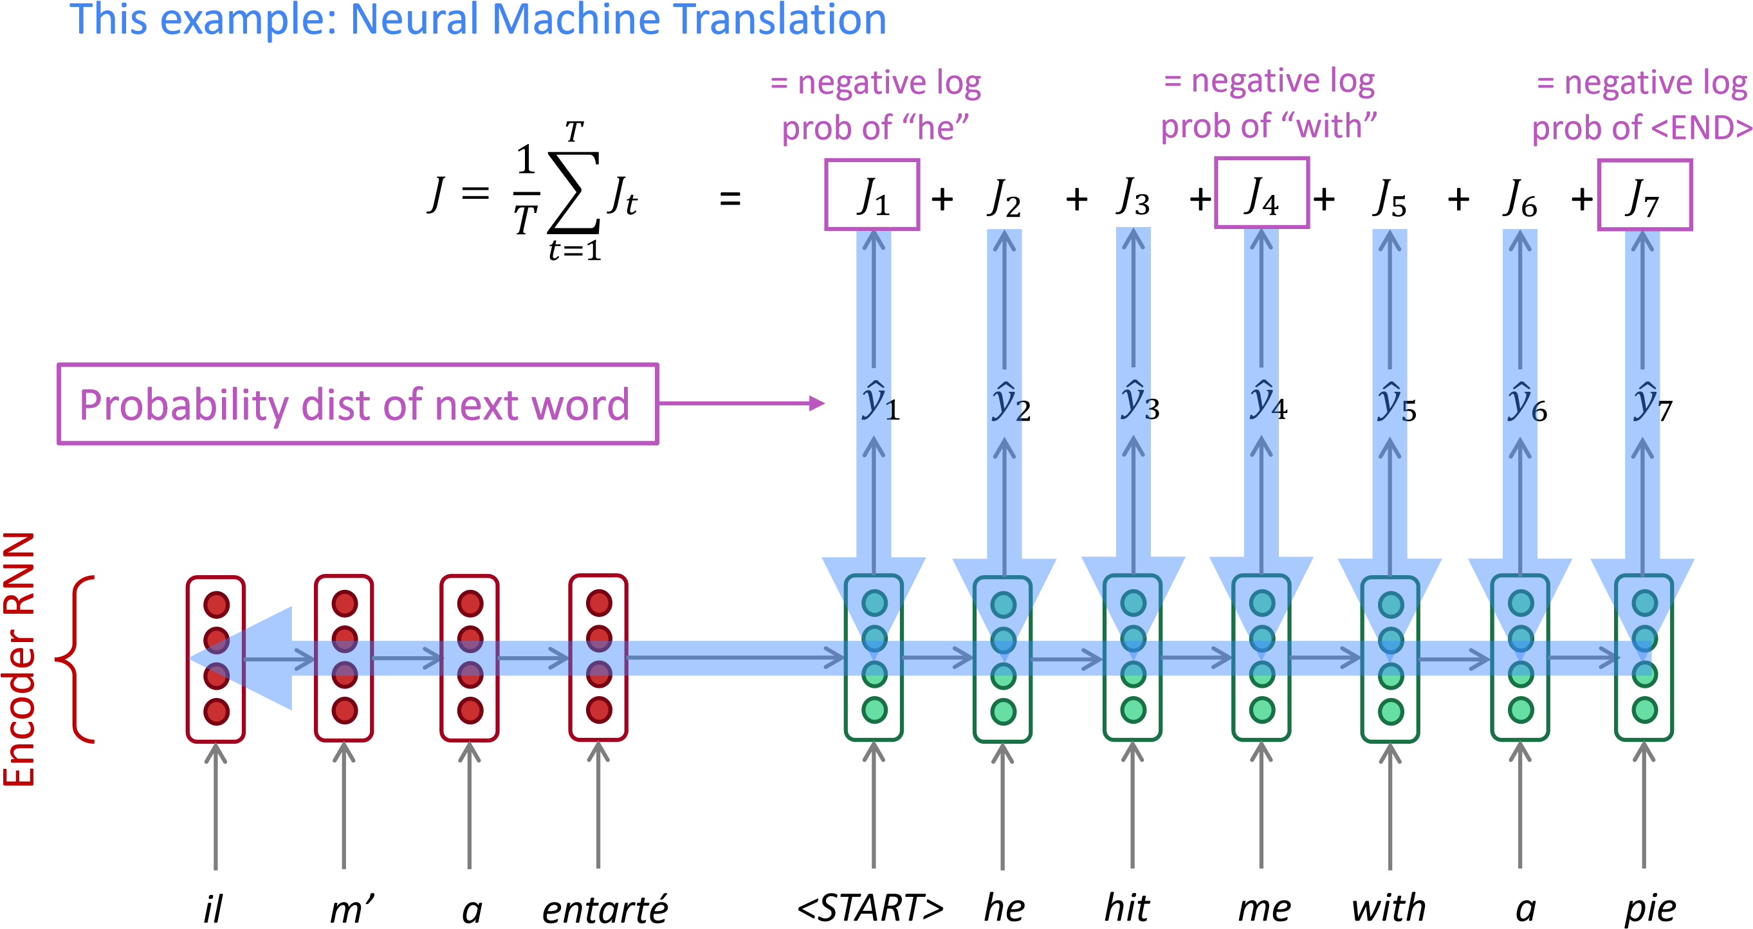

Decoder RNN

Source sentence (from corpus) Target sentence (from corpus)

During training, we feed the gold (aka reference) target sentence into the decoder, regardless of what the decoder predicts. This training method is called ***Teacher Forcing.***

# Recap: decoding algorithms

* Question: Once you’ve trained your (conditional) language model, how do you use it to generate text?
* Answer: A *decoding algorithm* is an algorithm you use to generate text from your language model
* We’ve learned about two decoding algorithms:
* Greedy decoding
* Beam search

# Recap: greedy decoding

* A simple algorithm
* On each step, take the most probable word (i.e. argmax)
* Use that as the next word, and feed it as input on the next step • Keep going until you produce <END> (**or reach some max length**)

*he hit me with a pie <END>*

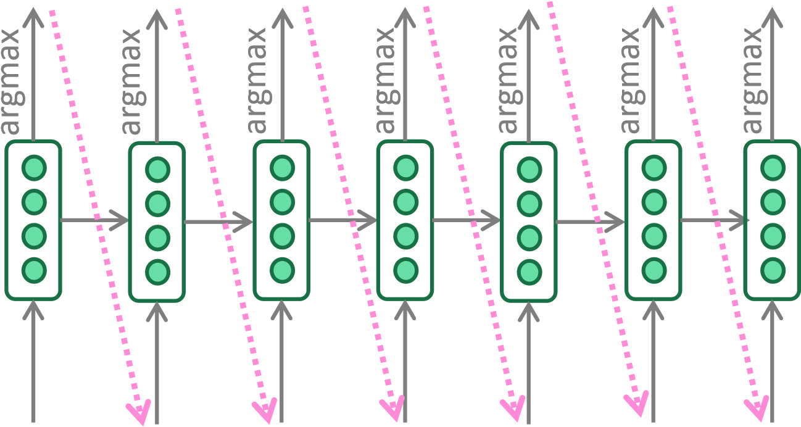

*<START> he hit me with a pie*

* Due to lack of backtracking, output can be poor

(e.g. ungrammatical, unnatural, nonsensical)

# Recap: beam search decoding

* A search algorithm which aims to find a high-probability sequence (not necessarily the optimal sequence, though) by tracking multiple possible sequences at once.
* Core idea: On each step of decoder, keep track of the *k* most probable partial sequences (which we call *hypotheses*)
* *k* is the beam size
* Expand hypotheses and then trim to keep only the best *k*
* After you reach some stopping criterion, choose the sequence with the highest probability (factoring in some adjustment for length)

# Recap: beam search decoding

Beam size =

*k*

2.

=

Blue numbers =

*hit*

*struck*

*was*

*got*

*a*

*me*

*hit*

*struck*

*tart*

*pie*

*with*

*on*

*in*

*with*

*a*

*one*

*pie*

*tart*

*pie*

*tart*

*<*

*>*

*START*

*he*

*I*

-

0.7

-

0.9

-

1.6

-

1.8

-

1.7

-

2.9

-

2.5

-

2.8

-

3.8

-

2.9

-

3.5

-

3.3

-

4.0

-

3.4

-

3.7

-

4.3

-

4.5

-

4.8

-

4.3

-

4.6

-

5.0

-

5.3

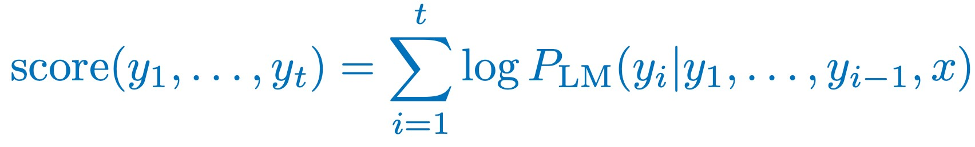

**Aside: Do the hosts in *Westworld* use beam search?**

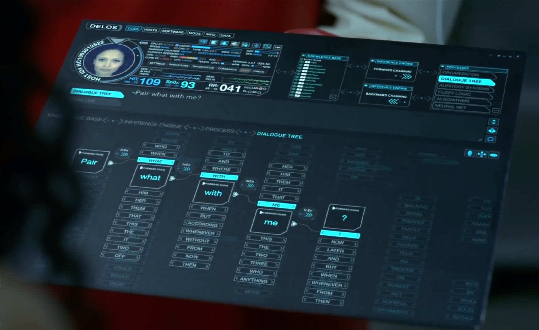

**KNOWLEDGE BASE!**

**FORWARD CHAINING!**

**BACKWARD CHAINING!**

**FUZZY LOGIC!**

**ALGORITHMS!**

**NEURAL NET!**

**BEAM SEARCH???**

Source: [https://www.youtube.com/watch?v=ZnxJRYit44k](https://www.youtube.com/watch%3Fv=ZnxJRYit44k)

**What’s the effect of changing beam size *k*?**

* Small *k* has similar problems to greedy decoding (*k*=1)
* Ungrammatical, unnatural, nonsensical, incorrect
* Larger *k* means you consider more hypotheses
* Increasing *k* reduces some of the problems above
* Larger *k* is more computationally expensive • But increasing *k* can introduce other problems:
* For NMT, increasing *k* too much decreases BLEU score (Tu et al, Koehn et al). This is primarily because large-k beam search produces tooshort translations (even with score normalization!)
* It can even produce empty translations (Stahlberg & Byrne 2019)
* In open-ended tasks like chit-chat dialogue, large *k* can make output more generic (see next slide)

*Neural Machine Translation with Reconstruction*, Tu et al, 2017 <https://arxiv.org/pdf/1611.01874.pdf>*Six Challenges for Neural Machine Translation*, Koehn et al, 2017 <https://arxiv.org/pdf/1706.03872.pdf>

# Effect of beam size in chitchat dialogue

|  |  |
| --- | --- |
| **Beam size** | **Model response** |
| 1 | *I love to eat healthy and eat healthy* |
| 2 | *That is a good thing to have* |
| 3 | *I am a nurse so I do not eat raw food* |
| 4 | *I am a nurse so I am a nurse* |
| 5 | *Do you have any hobbies?* |
| 6 | *What do you do for a living?* |
| 7 | *What do you do for a living?* |
| 8 | *What do you do for a living?* |

Human



*I mostly eat a*

*fresh and raw*

*diet, so I save*

*on groceries*

chit-chat partner **Low beam size:** More on-topic but nonsensical; bad English

**High beam size:**

Converges to safe, “correct” response, but it’s generic and less relevant

|  |
| --- |
| Both of theseare **more efficient** than beam search  –no multiple hypotheses |

# Sampling-based decoding

* Pure sampling
* On each step *t*, randomly sample from the probability distribution Pt to obtain your next word.
* Like greedy decoding, but sample instead of argmax.
* Top-n sampling*
* On each step *t*, randomly sample from Pt, restricted to just the top-n most probable words
* Like pure sampling, but truncate the probability distribution
* *n=1* is greedy search, *n=V* is pure sampling
* Increase *n* to get more diverse/risky output
* Decrease *n* to get more generic/safe output

*Usually called top-*k* sampling, but here we’re avoiding confusion with beam size *k*

# Sampling-based decoding

* Top-p sampling
* On each step *t*, randomly sample from Pt, restricted to just the top-p proportion of the most probable words
* Again, like pure sampling, but truncating the probability distribution
* This way you get a bigger sample when probability mass is spread
* Seems like it may be even better

Ari Holtzman, Jan Buys, Li Du, Maxwell Forbes, YejinChoi. The Curious Case of Neural Text Degeneration. *ICLR 2020.*

# Softmax temperature

* Recall: On timestep *t*, the LM computes a prob dist Pt by applying the softmax function to a vector of scores 𝑠 ∈ ℝ|"|

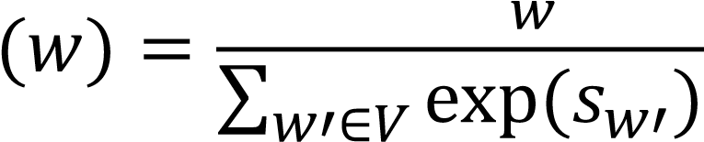exp(𝑠 )

𝑃#

* You can apply a *temperature hyperparameter* 𝜏 to the softmax:

𝑃# 𝑤 = ∑$+exp∈" exp𝑠$/𝑠𝜏$+/𝜏

* Raise the temperature 𝜏: 𝑃# becomes more uniform
* Thus more diverse output (probability is spread around vocab)
* Lower the temperature 𝜏:𝑃# becomes more spiky
* Thus less diverse output (probability is concentrated on top words)

**Note: softmax temperature is not a decoding algorithm!**

It’s a technique you can apply at test time, in conjunction with a decoding algorithm (such as beam search or sampling)

# Decoding algorithms: in summary

* **Greedy decoding** is a simple method; gives low quality output
* **Beam search** (especially with high beam size) searches for highprobability output
* Delivers better quality than greedy, but if beam size is too high, can return high-probability but unsuitable output (e.g. generic, short)
* **Sampling methods** are a way to get more diversity and randomness
* Good for open-ended / creative generation (poetry, stories)
* Top-n/p sampling allows you to control diversity
* **Softmax temperature** is another way to control diversity
* It’s not a decoding algorithm! It's a technique that can be applied alongside any decoding algorithm.

**Section 2:**

# NLG tasks and neural approaches to them Summarization: task definition

Task: given input text *x*, write a summary *y* which is shorter and contains the main information of *x*.

Summarization can be single-document or multi-document.

* Single-document means we write a summary *y* of a single document *x*.
* Multi-document means we write a summary *y* of *multiple* documents *x*1,…,*x*n

Typically *x*1,…,*x*n have overlapping content: e.g. news articles about the same event

# Summarization: task definition

Within single-document summarization, there are datasets with source documents of different lengths and styles:

* Gigaword: first one or two sentences of a news article → headline (aka *sentence compression*)
* LCSTS (Chinese microblogging): paragraph → sentence summary
* NYT, CNN/DailyMail: news article → (multi)sentence summary
* Wikihow: full how-to article → summary sentences
* XSum: (Narayan et al., 2018), Newsroom: (Grusky et al., 2018): article → 1 sentence summary (New datasets!)

*Sentence simplification* is a different but related task:

rewrite the source text in a simpler (sometimes shorter) way • Simple Wikipedia: standard Wikipedia sentence → simple version

* Newsela: news article → version written for children

List of summarization datasets, papers, and codebases: <https://github.com/mathsyouth/awesome-text-summarization>

# Summarization: two main strategies

## Extractive summarization

*Select parts (typically sentences) of the original text to form a summary.*



## Abstractive summarization

*Generate new text using natural language generation techniques.*



* Easier
* Restrictive (no paraphrasing)

23

* More difficult
* More flexible (more human)

# Pre-neural summarization

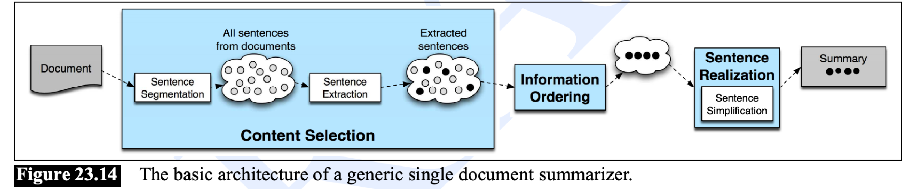

* Pre-neural summarization systems were mostly extractive
* Like pre-neural MT, they typically had a pipeline:
* **Content selection**: choose some sentences to include • **Information ordering**: choose an ordering of those sentences
* **Sentence realization**: edit the sequence of sentences (e.g. simplify, remove parts, fix continuity issues)

Diagram credit: *Speech and Language Processing*, Jurafsky and Martin

# Pre-neural summarization



Pre-neural **content selection** algorithms:

* Sentence scoring functions can be based on:
* Presence of topic keywords, computed via e.g. tf-idf
* Features such as where the sentence appears in the document
* Graph-based algorithms view the document as a set of sentences (nodes), with edges between each sentence pair
* Edge weight is proportional to sentence similarity
* Use graph algorithms to identify sentences which are *central* in the graph

Diagram credit: *Speech and Language Processing*, Jurafsky and Martin

# Summarization evaluation: ROUGE

**ROUGE** (Recall-Oriented Understudy for Gisting Evaluation)

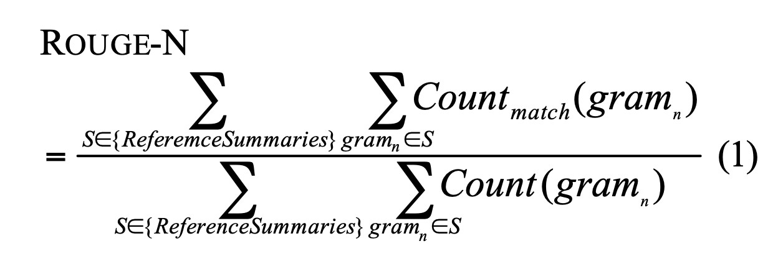

Like BLEU, it’s based on n-gram overlap. Differences:

* ROUGE has no brevity penalty
* ROUGE is based on recall, while BLEU is based on precision
* Arguably, precision is more important for MT (then add brevity penalty to fix under-translation), and recall is more important for summarization

(assuming you have a max length constraint)

* However, often a F1 (combination of precision and recall) version of ROUGE is reported anyway.

*ROUGE: A Package for Automatic Evaluation of Summaries*, Lin, 2004 <http://www.aclweb.org/anthology/W04-1013>

# Summarization evaluation: ROUGE

* BLEU is reported as a single number, which is combination of the precisions for n=1,2,3,4 n-grams
* ROUGE scores are reported separately for each n-gram
* The most commonly-reported ROUGE scores are:
* ROUGE-1:* unigram overlap
* ROUGE-2: bigram overlap
* ROUGE-L: longest common subsequence overlap
* There is now a convenient Python implementation of ROUGE!
* https://github.com/pltrdy/rouge

*not to be confused with *ROGUE ONE: A Star Wars Story* Python implementation of ROUGE: <https://github.com/google-research/google-research/tree/master/rouge>

# Neural summarization (2015 - present)

• 2015: Rush et al. publish the first seq2seq summarization paper • Single-document abstractive summarization is a translation task! • Thus we can apply standard seq2seq + attention NMT methods

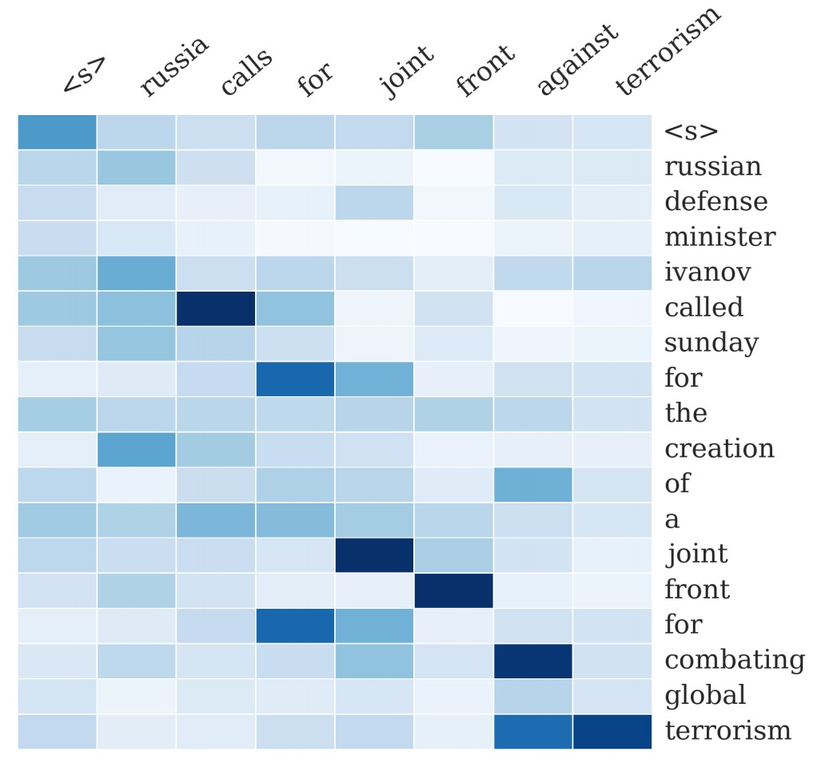

*A Neural Attention Model for Abstractive Sentence Summarization*, Rush et al, 2015 <https://arxiv.org/pdf/1509.00685.pdf>

# Neural summarization (2015 - present)

* Since 2015, there have been lots more developments!
* Making it easier to copy • But also preventing too much copying!
* Hierarchical / multi-level attention
* More global / high-level content selection
* Using Reinforcement Learning to directly maximize ROUGE, or other discrete goals (e.g., length)
* Resurrecting pre-neural ideas (e.g., graph algorithms for content selection) and working them into neural systems
* …

List of summarization datasets, papers, and codebases: <https://github.com/mathsyouth/awesome-text-summarization>*A Survey on Neural Network-Based Summarization Method*s, Dong, 2018 <https://arxiv.org/pdf/1804.04589.pdf>

# Neural summarization: copy mechanisms

* Seq2seq+attention systems are good at writing fluent output, but bad at copying over details (like rare words) correctly
* Copy mechanisms use attention to enable a seq2seq system to easily copy words and phrases from the input to the output
* Clearly this is very useful for summarization
* Allowing both copying and generating gives us a hybrid extractive/abstractive approach
* There are other papers proposing copy mechanism variants:
* Language as a Latent Variable: Discrete Generative Models for Sentence Compression, Miao et al, 2016 <https://arxiv.org/pdf/1609.07317.pdf>
* Abstractive Text Summarization using Sequence-to-sequence RNNs and Beyond, Nallapatiet al, 2016 <https://arxiv.org/pdf/1602.06023.pdf>
* Incorporating Copying Mechanism in Sequence-to-Sequence Learning, Gu et al, 2016 <https://arxiv.org/pdf/1603.06393.pdf>
* etc.

# Neural summarization: copy mechanisms

See et al, 2017, *Get To The Point: Summarization with Pointer-Generator Networks*, <https://arxiv.org/pdf/1704.04368.pdf>

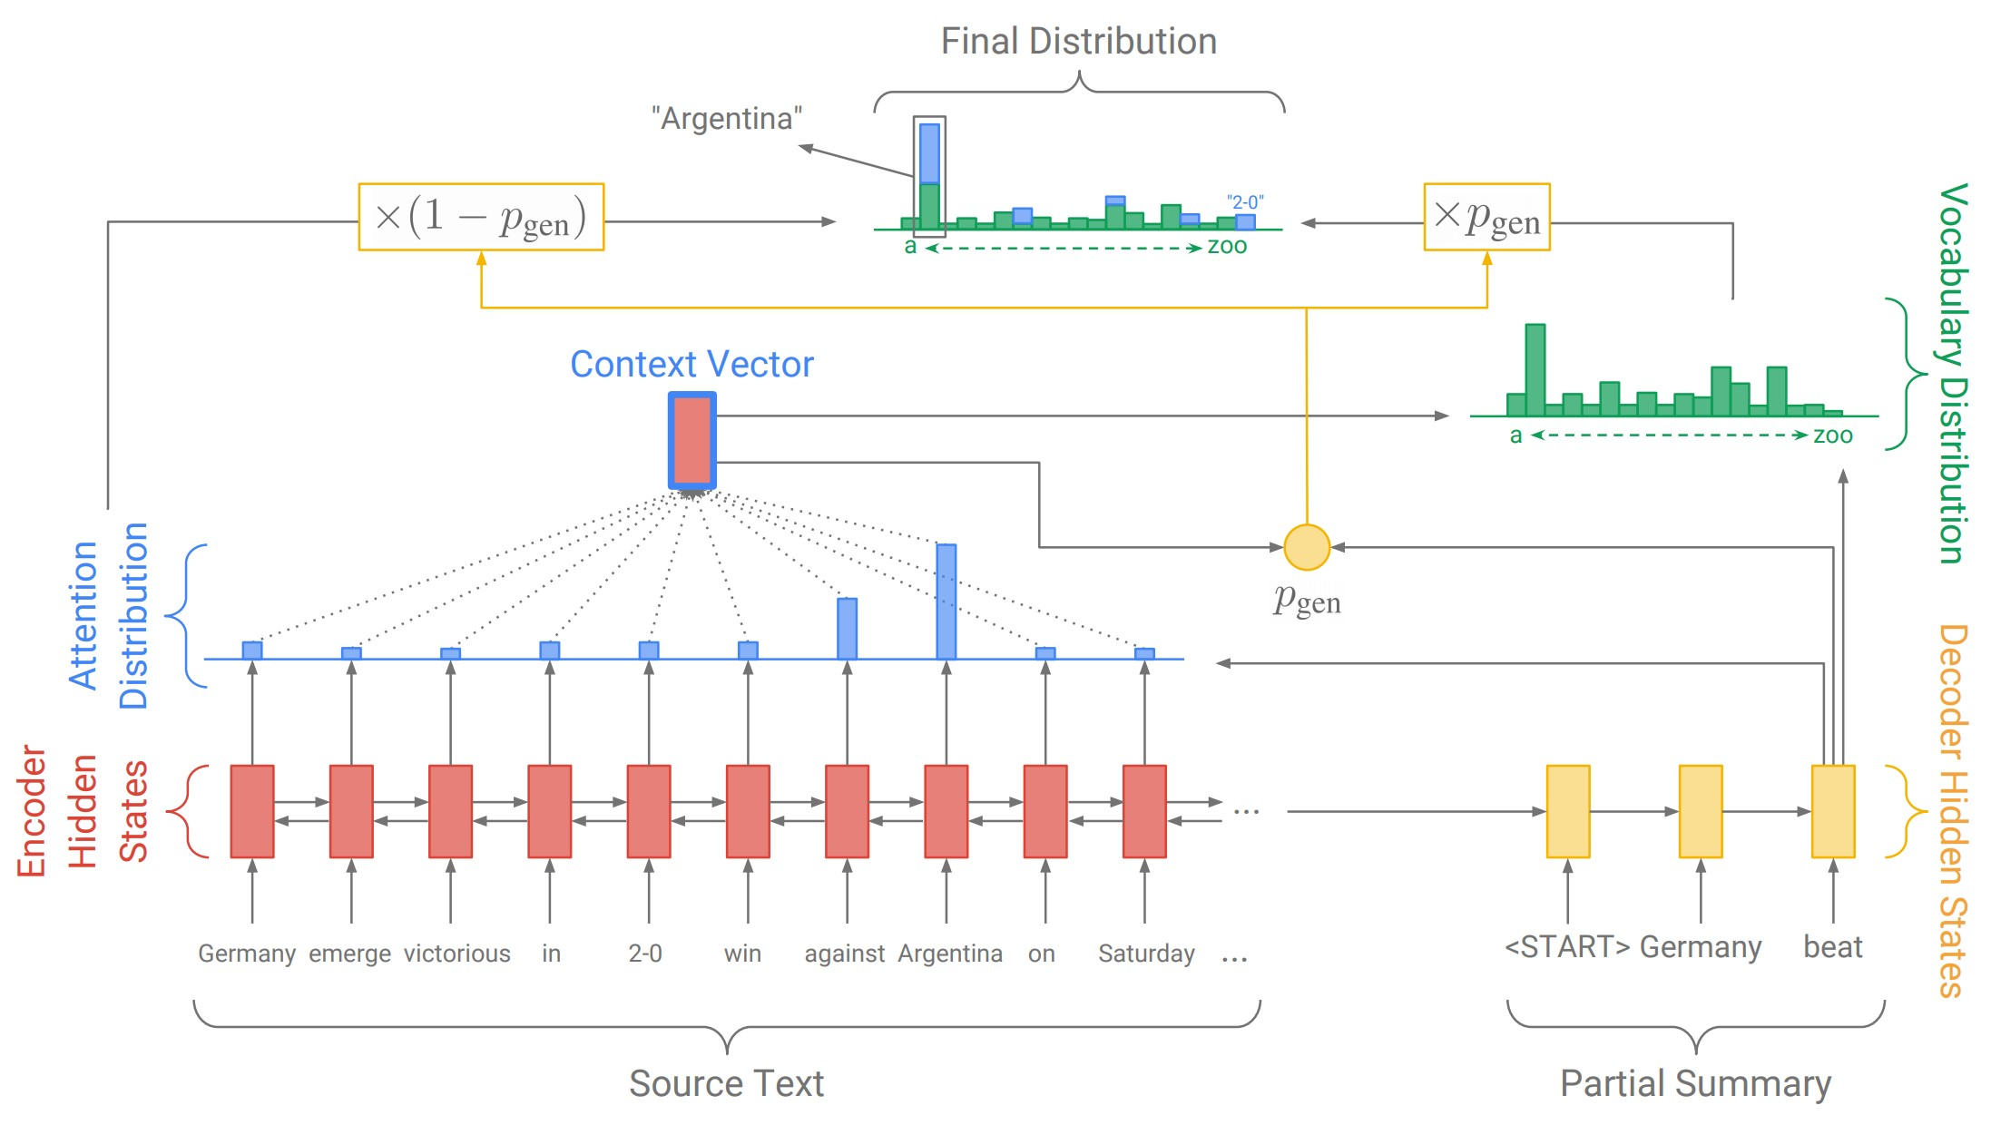

One example of how to do a copying mechanism:

On each decoder step, calculate pgen, the probability of *generating* the next word (rather than copying it). The final distribution is a mixture of the generation (aka “vocabulary”) distribution, and the copying (i.e. attention) distribution:

31

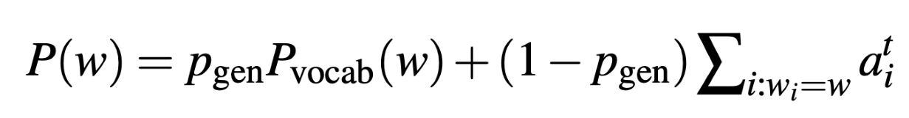

# Neural summarization: copy mechanisms

* Big problem with copying mechanisms:
* **They copy too much!**
* Mostly long phrases, sometimes even whole sentences
* What *should* be an abstractive system collapses to a mostly extractive system.
* Another problem:
* They’re bad at overall content selection, especially if the input document is long
* No overall strategy for selecting content

# Neural summarization: better content selection

* Recall: pre-neural summarization had separate stages for **content selection** and **surface realization** (i.e. text generation)
* In a standard seq2seq+attention summarization system, these two stages are mixed in together
* On each step of the decoder (i.e. surface realization), we do word-level content selection (attention)
* This is bad: no *global* content selection strategy
* One solution: bottom-up summarization

# Bottom-up summarization

* Content selection stage: Use a neural sequence-tagging model to tag words as *include* or *don’t-include*
* Bottom-up attention stage: The seq2seq+attention system can’t attend to words tagged *don’t-include* (apply a mask)

**Simple but effective!**

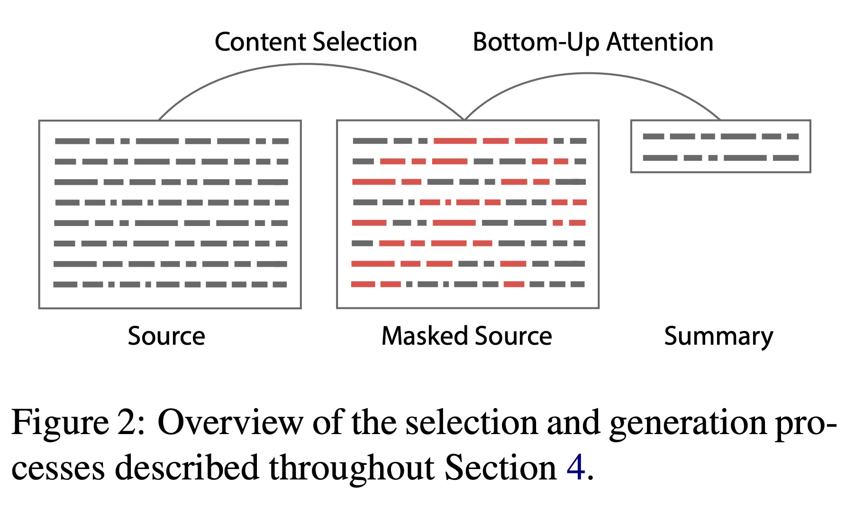

* Better overall content selection strategy
* Less copying of long sequences (i.e. more abstractive output)

*Bottom-Up Abstractive Summarization*, Gehrmann et al, 2018 <https://arxiv.org/pdf/1808.10792v1.pdf>

**Neural summarization via Reinforcement Learning**

* In 2017 Paulus et al published a “deep reinforced” summarization model
* Main idea: Use Reinforcement Learning (RL) to directly optimize ROUGE-L
* By contrast, standard maximum likelihood (ML) training can’t directly optimize ROUGE-L because it’s a non-differentiable function
* Interesting finding:
* Using RL instead of ML achieved higher ROUGE scores, but lower human

judgment scores

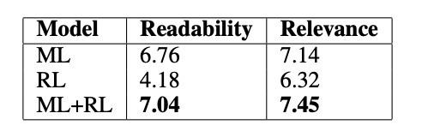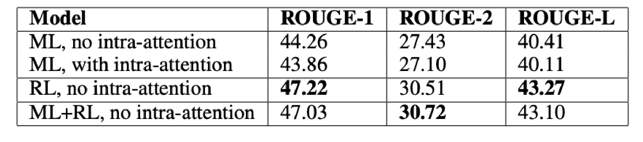

*“We observed that our models with the*

*highest ROUGE scores also generated barely*

*-*

*readable summaries.”*

Overall, a hybrid approach does best!

*A Deep Reinforced Model for Abstractive Summarization*, Paulus et al, 2017 <https://arxiv.org/pdf/1705.04304.pdf>

Blog post: <https://www.salesforce.com/products/einstein/ai-research/tl-dr-reinforced-model-abstractive-summarization/>

# Dialogue

“Dialogue” encompasses a large variety of settings:

## • Task-oriented dialogue

* Assistive (e.g. customer service, giving recommendations, question answering, helping user accomplish a task like buying or booking something)
* Co-operative (two agents solve a task together through dialogue)
* Adversarial (two agents compete in a task through dialogue)
* **Social dialogue**
* Chit-chat (for fun or company)
* Therapy / mental wellbeing

# Pre- and post-neural dialogue

* Due to the difficulty of open-ended freeform NLG, pre-neural dialogue systems more often used predefined templates, or retrieve an appropriate response from a corpus of responses.
* As in summarization research, since 2015 there have been many papers applying seq2seq methods to dialogue – thus leading to a renewed interest in open-ended freeform dialogue systems
* Some early seq2seq dialogue papers include:
* *A Neural Conversational Model*, Vinyals et al, 2015 <https://arxiv.org/pdf/1506.05869.pdf>
* *Neural Responding Machine for Short-Text Conversation*, Shang et al, 2015 <https://www.aclweb.org/anthology/P15-1152>

This is a nice overview of recent (mostly neural) conversational conversational AI work:

<https://medium.com/gobeyond-ai/a-reading-list-and-mini-survey-of-conversational-ai-32fceea97180>

# Seq2seq-based dialogue

* However, it quickly became apparent that a naïve application of standard seq2seq+attention methods has serious pervasive deficiencies for (chitchat) dialogue:
* Genericness / boring responses
* Irrelevant responses (not sufficiently related to context)
* Repetition
* Lack of context (not remembering conversation history) • Lack of consistent persona

# Irrelevant response problem

* Problem: seq2seq often generates response that’s unrelated to user’s utterance
* Either because it’s generic (e.g. *“I don’t know”*)
* Or because changing the subject to something unrelated
* One solution: optimize for Maximum Mutual Information (MMI) between input S and response T:

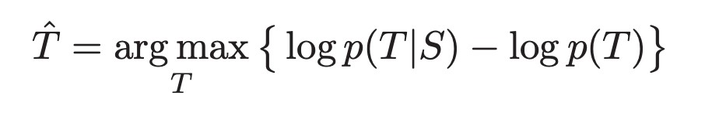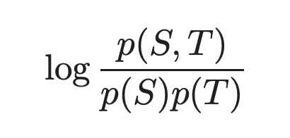

*A Diversity-Promoting Objective Function for Neural Conversation Models*, Li et al, 2016 <https://arxiv.org/pdf/1510.03055.pdf>

# Genericness / boring response problem

* Easy test-time fixes:
* Directly upweight rare words during beam search
* Use a sampling decoding algorithm rather than beam search • Conditioning fixes:
* Condition the decoder on some additional content (e.g. sample some content words and attend to them)
* Train a retrieve-and-refine model rather than a generatefrom-scratch model
* i.e. sample an utterance from your corpus of human-written utterances, and edit it to fit the current scenario.
* This usually produces much more diverse / human-like / interesting utterances!

Why are Sequence-to-Sequence Models So Dull?, Jiang et al, 2018

<https://staff.fnwi.uva.nl/m.derijke/wp-content/papercite-data/pdf/jiang-why-2018.pdf>

# Repetition problem

Simple solution:

* Directly block repeating n-grams during beam search.
* Usually pretty effective!

More complex solutions:

* Train a coverage mechanism – in seq2seq, this is an objective that prevents the attention mechanism from attending to the same words multiple times.
* Define a training objective to discourage repetition
* If this is a non-differentiable function of the generated output, then will need some technique like e.g. RL to train

# Lack of consistent persona problem

* In 2016, Li et al proposed a seq2seq dialogue model that learns to encode both conversation partners’ personas as embeddings
* The generated utterances are conditioned on the embeddings
* There is now a chitchat dataset called PersonaChat, which includes personas (collections of 5 sentences describing personal traits) for every conversation.
* This provides a light type of *grounding*, allowing researchers to build persona-conditional dialogue agents

*A Persona-Based Neural Conversation Model*, Li et al 2016, <https://arxiv.org/pdf/1603.06155.pdf>*Personalizing Dialogue Agents: I have a dog, do you have pets too?*, Zhang et al, 2018 <https://arxiv.org/pdf/1801.07243.pdf>

In 2017, Lewis et al collected a negotiation dialogue dataset

* Two agents negotiate (via natural language) how to divide a set of items.
* The agents have different value functions for the items.
* The agents talk until they reach an agreement.



*Deal or No Deal? End-to-End Learning for Negotiation Dialogues*, Lewis et al, 2017 <https://arxiv.org/pdf/1706.05125.pdf>

* They find that training seq2seq systems for the standard maximum likelihood (ML) objective yields fluent but strategically poor dialogue agents.
* Like the Paulus et al summarization paper, they use

Reinforcement Learning to optimize for a discrete reward (with the agents playing against themselves during training)

* The RL goal-based objective is combined with the ML objective
* Potential pitfall: If the agents just optimize just the RL goal while playing against each other, they might diverge from English*

*This observation led to an unfortunate media over-reaction: <https://www.skynettoday.com/briefs/facebook-chatbot-language/>*Deal or No Deal? End-to-End Learning for Negotiation Dialogues*, Lewis et al, 2017 <https://arxiv.org/pdf/1706.05125.pdf>

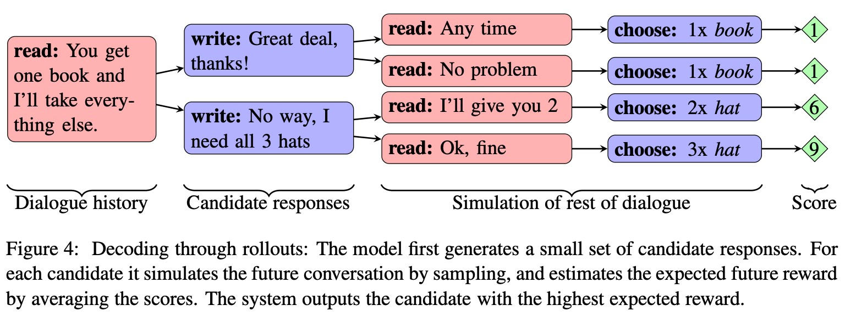

* At test time, the model chooses between possible responses by computing rollouts: simulations of the rest of the conversation and the expected reward.

*Deal or No Deal? End-to-End Learning for Negotiation Dialogues*, Lewis et al, 2017 <https://arxiv.org/pdf/1706.05125.pdf>

* In 2018, Yarats et al proposed another dialogue model for the negotiation task, that separates the strategic aspect from the NLG aspect.
* This separation was standard in “old” discourse/dialog NLG approaches
* Each utterance xt has a corresponding discrete latent variable zt
* zt is learned to be a good predictor of future events in the dialogue (future messages, ultimate strategic outcome), but not a predictor of xt itself
* This means that *“zt learns to represent xt’s effect on the dialogue, but not the words of xt”*
* Thus zt separates the strategic aspect of the task from the NLG aspect. This is useful for controllability, interpretability, easier to learn strategy, etc.

*Hierarchical Text Generation and Planning for Strategic Dialogue*, Yarats et al, 2018 <https://arxiv.org/pdf/1712.05846.pdf>

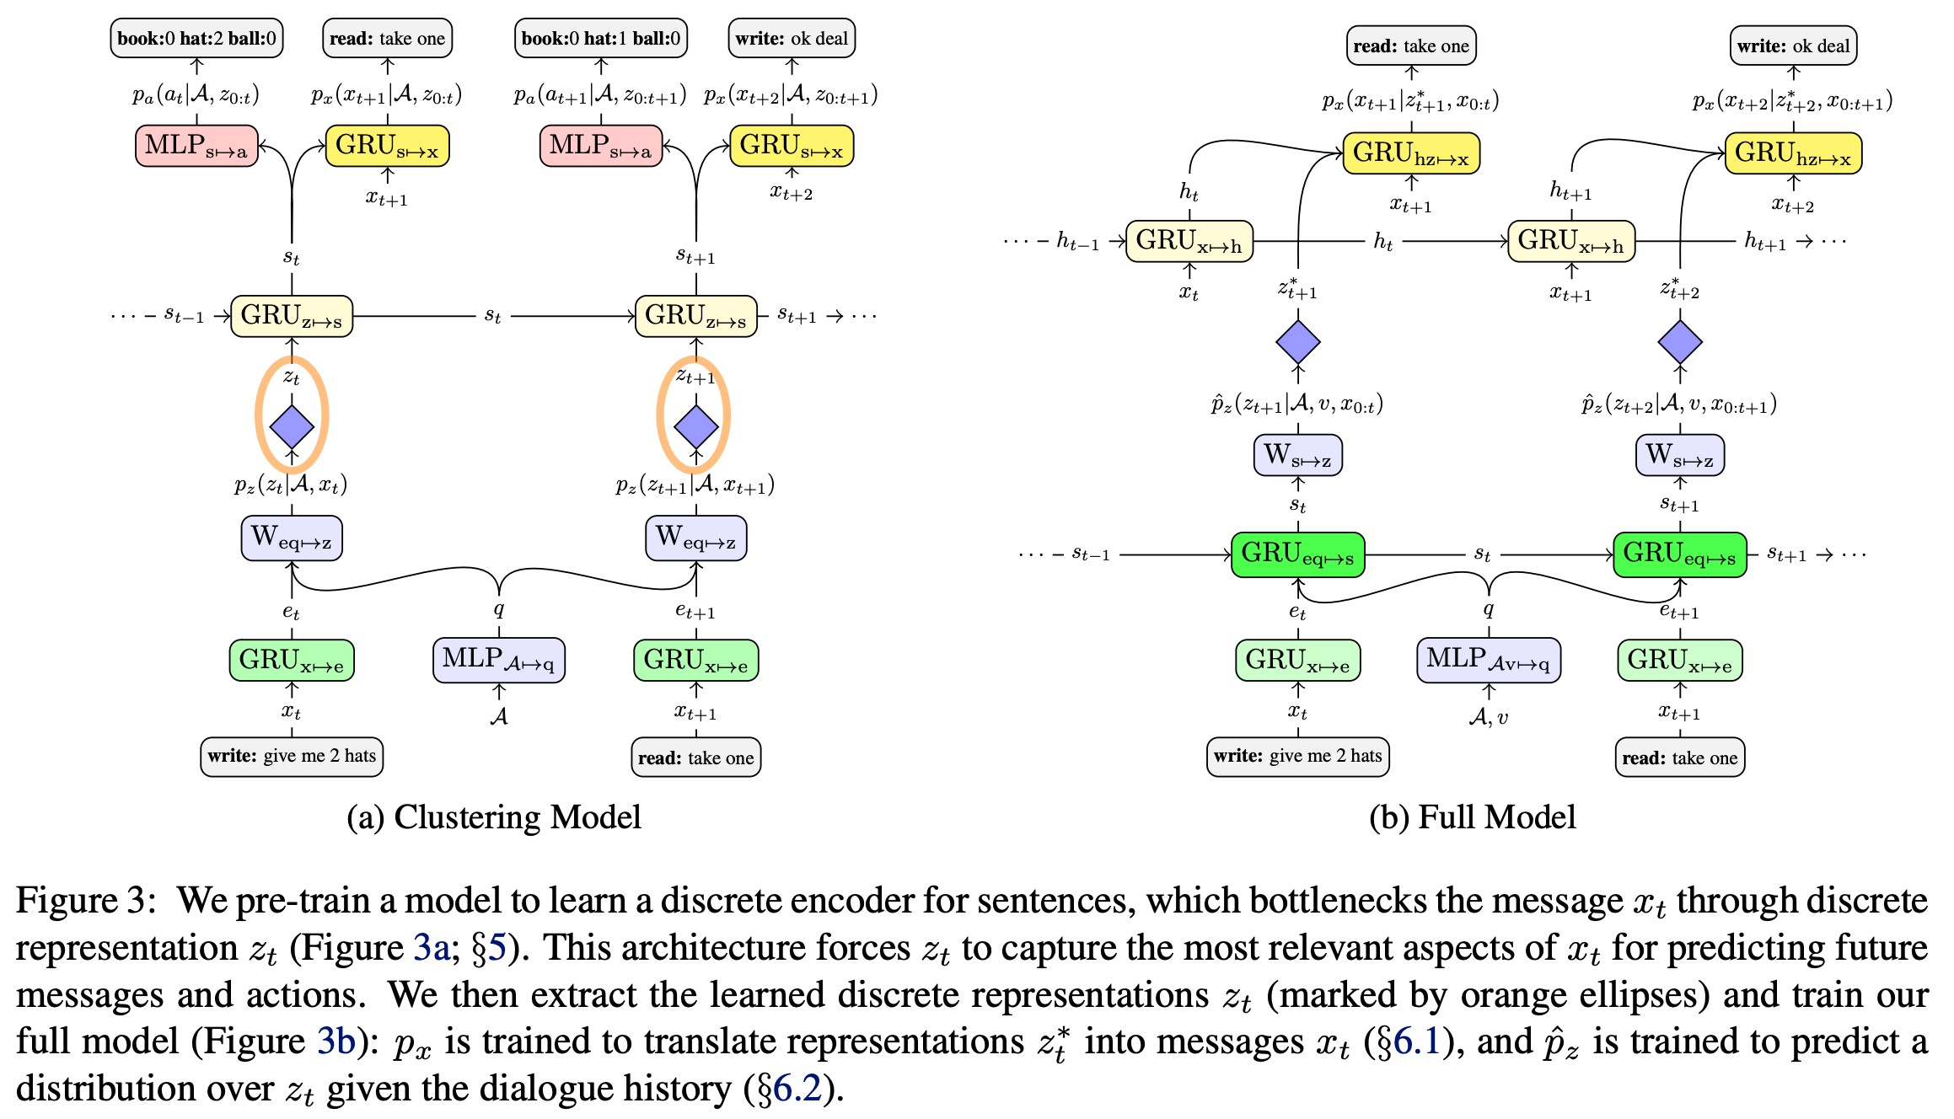

*Hierarchical Text Generation and Planning for Strategic Dialogue*, Yarats et al, 2018 <https://arxiv.org/pdf/1712.05846.pdf>

# Conversational question answering: CoQA

* A new dataset from Stanford NLP!

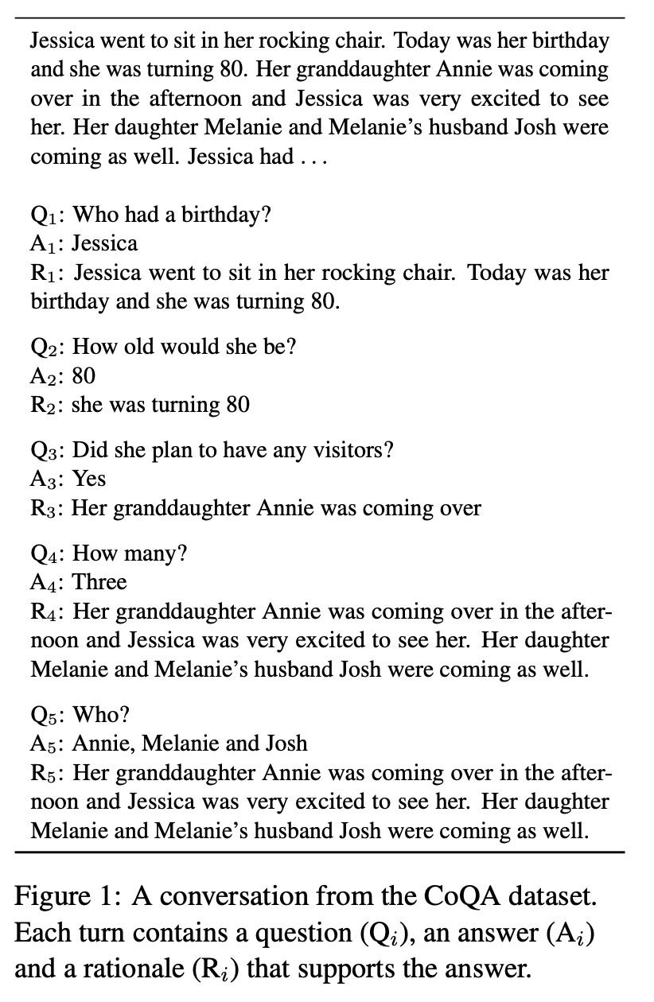

* Task: answer questions about a piece of text *within the context of a conversation*
* Answers can be abstractive (i.e. not a copied span)
* But a large percent are spans
* Both a QA / readingcomprehension task, and a dialogue task

*CoQA: a Conversational Question Answering Challenge*, Reddy et al, 2018 <https://arxiv.org/pdf/1808.07042.pdf>

# Storytelling

* Most neural storytelling work uses some kind of prompt
* Generate a story-like paragraph given an image
* Generate a story given a brief writing prompt
* Generate the next sentence of a story, given the story so far

(*story continuation*)

* This is different to the previous two, because we are not concerned with the system’s performance over several generated sentences
* Neural storytelling is taking off!
* The first Storytelling Workshop was held in 2018
* It held a competition (generate a story to accompany a sequence of 5 images)

Storytelling Workshop 2019: <http://www.visionandlanguage.net/workshop2019/>

# Generating a story from an image

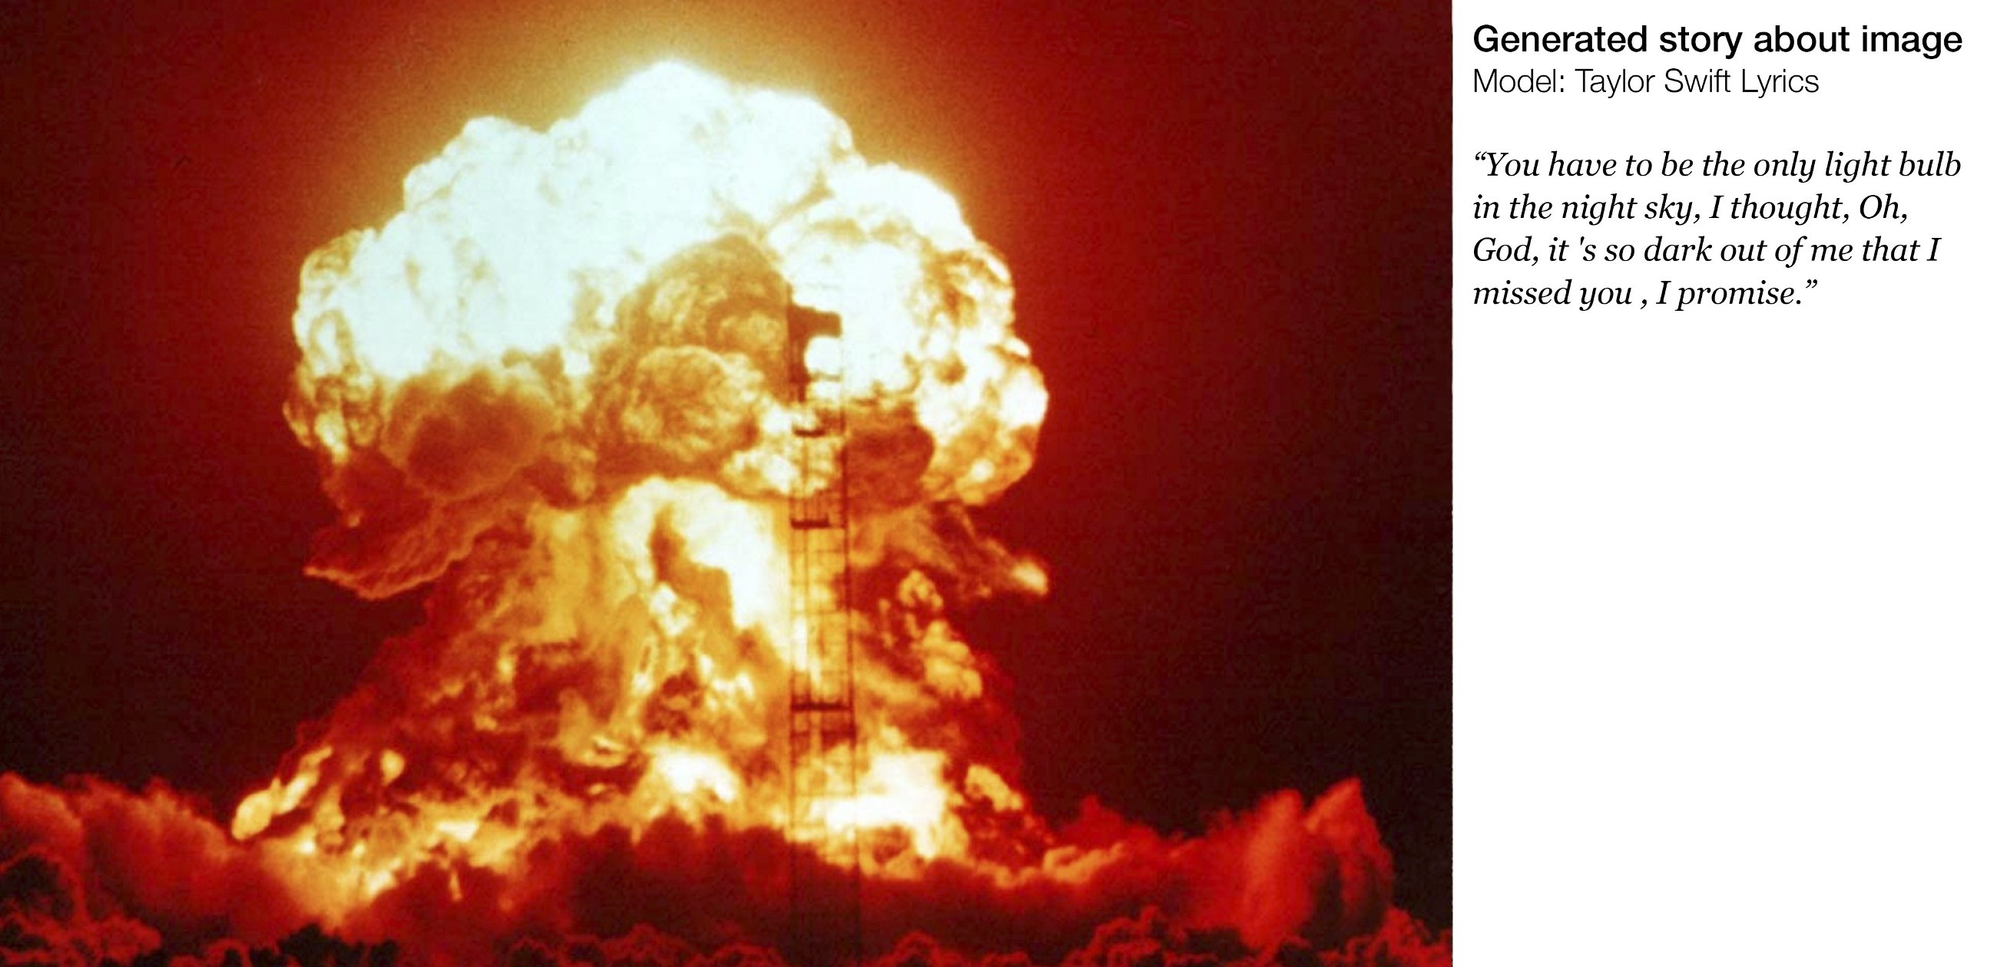

What’s interesting here is that this isn’t straightforward supervised image-captioning.

There was no paired data to learn from.

*Generating Stories about Images*, <https://medium.com/@samim/generating-stories-about-images-d163ba41e4ed>

# Generating a story from an image

* Question: How to get around the lack of parallel data?
* Answer: Use a common sentence-encoding space
* Skip-thought vectors are a type of general-purpose sentence embedding method
* The idea is similar to how we learn an embedding for a word by trying to predict the words around it
* Using COCO (an image captioning dataset), learn a mapping from images to the skip-thought encodings of their captions
* Using the target style corpus (Taylor Swift lyrics), train a RNN-LM to decode a skip-thought vector to the original text
* Put the two together

*Generating Stories about Images*, <https://medium.com/@samim/generating-stories-about-images-d163ba41e4ed>*Skip-Thought Vectors*, Kiros 2015, <https://arxiv.org/pdf/1506.06726v1.pdf>

* In 2018, Fan et al released a new story generation dataset collected from Reddit’s WritingPrompts subreddit.
* Each story has an associated brief writing prompt.

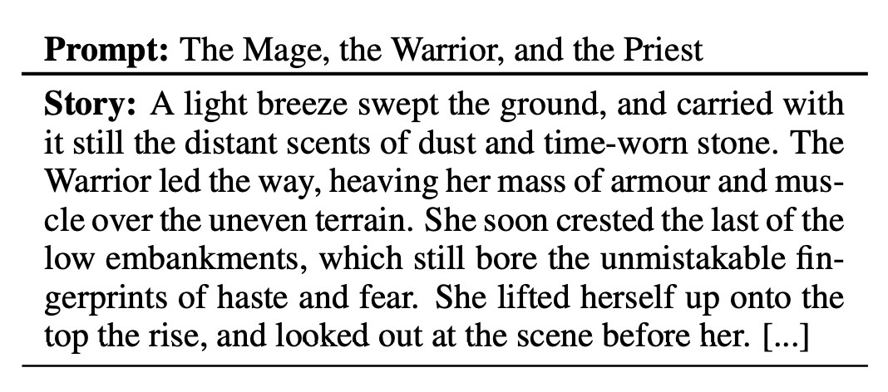

Fan et al also proposed a complex seq2seq prompt-to-story model:

* It’s convolutional-based • This makes it faster than RNN-based seq2seq
* Gated multi-head multi-scale self-attention
* The self-attention is important for capturing long-range context
* The gates allow the attention mechanism to be more selective
* The different attention heads attend at different scales – this means there are different attention mechanisms dedicated to retrieving finegrained information and coarse-grained information
* Model fusion:
* Pretrain one seq2seq model, then train a *second* seq2seq model that has access to the hidden states of the first
* The idea is that the first seq2seq model learns general LM and the second learns to condition on the prompt

The results are impressive!

* Related to prompt
* Diverse; non-generic
* 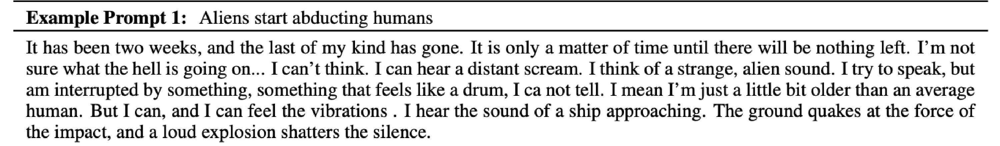Stylistically dramatic

However:

* Mostly atmospheric/descriptive/scene-setting; less events/plot
* When generating for longer, mostly stays on the same idea without moving forward to new ideas – coherence issues

**But GPT-2 straight transformer LM output also good!**

|  |  |
| --- | --- |
| SYSTEM  PROMPT  (HUMANWRITTEN)  MODEL  COMPLETION  (MACHINE-  WRITTEN,  10 TRIES) | *In a shocking finding, scientist discovered a herd of unicorns living in a remote, previously unexplored valley, in the Andes Mountains. Even more surprising to the researchers was the fact that the unicorns spoke perfect English.*  The scientist named the population, after their distinctive horn, Ovid’s Unicorn. These four-horned, silver-white unicorns were previously unknown to science.  Now, after almost two centuries, the mystery of what sparked this odd phenomenon is finally solved.  Dr. Jorge Pérez, an evolutionary biologist from the University of  La Paz, and several companions, were exploring the Andes Mountains when they found a small valley, with no other animals or humans. Pérez noticed that the valley had what appeared to be a natural fountain, surrounded by two peaks of rock and silver snow. |

Pérez and the others then ventured further into the valley. …

55

# Challenges in storytelling

Stories generated by neural LMs can sound fluent… but are meandering, nonsensical, with no coherent plot

**What’s missing?**

LMs model *sequences of words*. Stories are *sequences of events*.

* To tell a story, we need to understand and model:
* Events and the causality structure between them
* Characters, their personalities, motivations, histories, and relationships to other characters
* State of the world (who and what is where and why)
* Narrative structure (e.g. exposition → conflict → resolution)
* Good storytelling principles (don’t introduce a story element then never use it)

# Challenges in storytelling

Stories generated by neural LMs can sound fluent… but are meandering, nonsensical, with no coherent plot

**What’s missing?**

LMs model *sequences of words*. Stories are *sequences of events*.

* To tell a story, we need to understand and model:
* Events and the causality structure between them
* Characters, their personalities, motivations, histories, and relationships to other characters
* State of the world (who and what is where and why)
* Narrative structure (e.g. exposition → conflict → resolution)
* Good storytelling principles (don’t introduce a story element 57 then never use it)

THIS IS INCREDIBLY DIFFICULT

# Event2event Story Generation

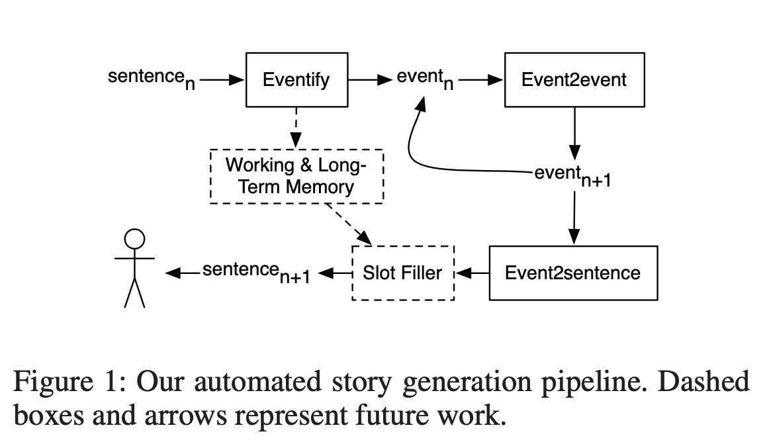

*Event Representations for Automated Story Generation with Deep Neural Nets*, Martin et al, 2018 <https://www.aaai.org/ocs/index.php/AAAI/AAAI18/paper/view/17046/15769>

# Structured Story Generation

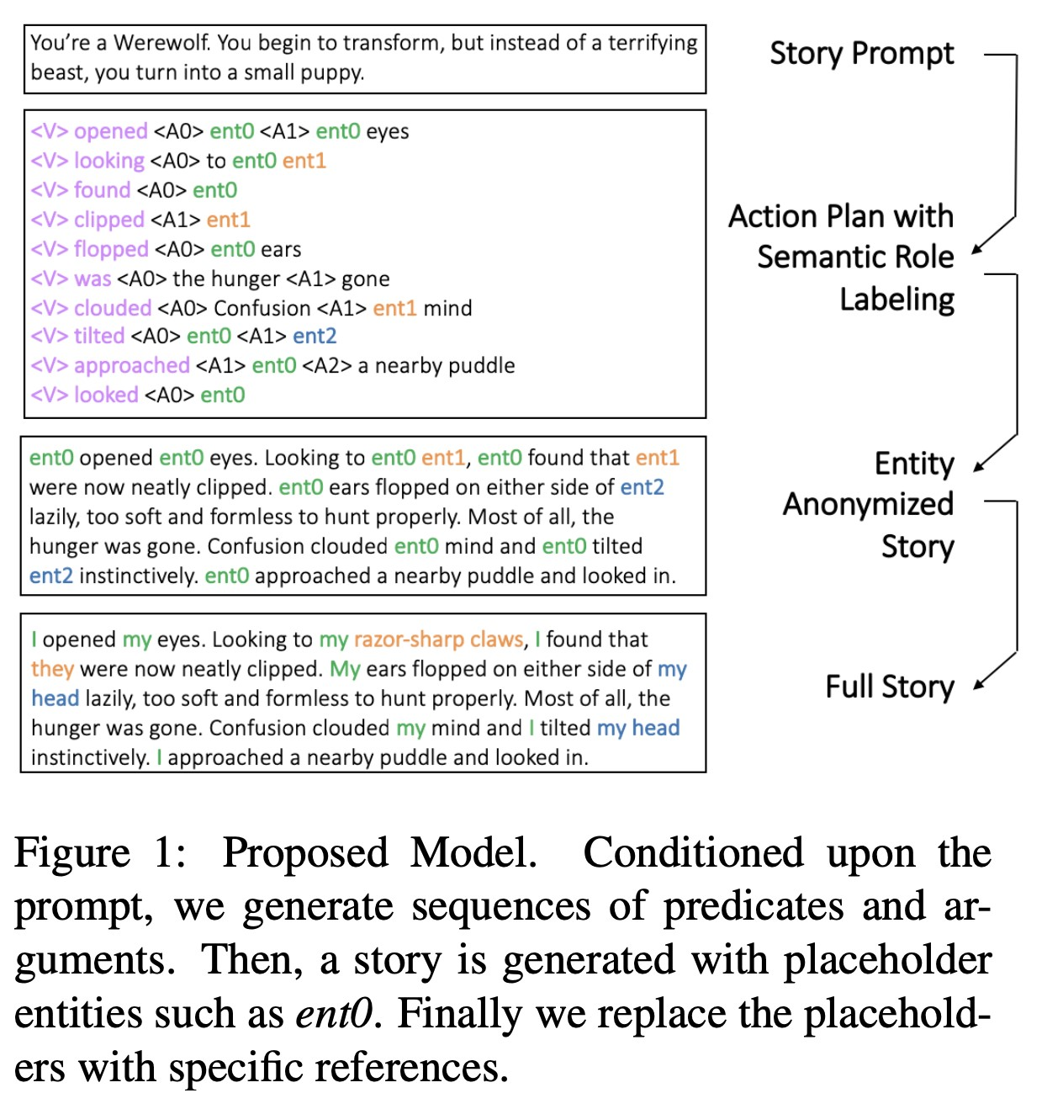

*Strategies for Structuring Story Generation*, Fan et al, 2019 <https://arxiv.org/pdf/1902.01109.pdf>

**Tracking events, entities, state, etc.**

* Sidenote: there’s been lots of work on tracking events/ entities/state in neural NL**U** (natural language **understanding**)
* For example, Yejin Choi’s group* does lots of work in this area
* Applying these methods to NLG is even more difficult • It’s more manageable if you narrow the scope:
* Instead of generating open-domain natural language stories while tracking state…
* generate a recipe (given the ingredients) while tracking the state of the ingredients!

*Yejin Choi research group: <https://homes.cs.washington.edu/~yejin/>

# Tracking world state while generating a recipe

* Neural Process Network: generates recipe instructions, given the ingredients
* Explicitly tracks the state of all the ingredients, and uses this to decide what action to take next.

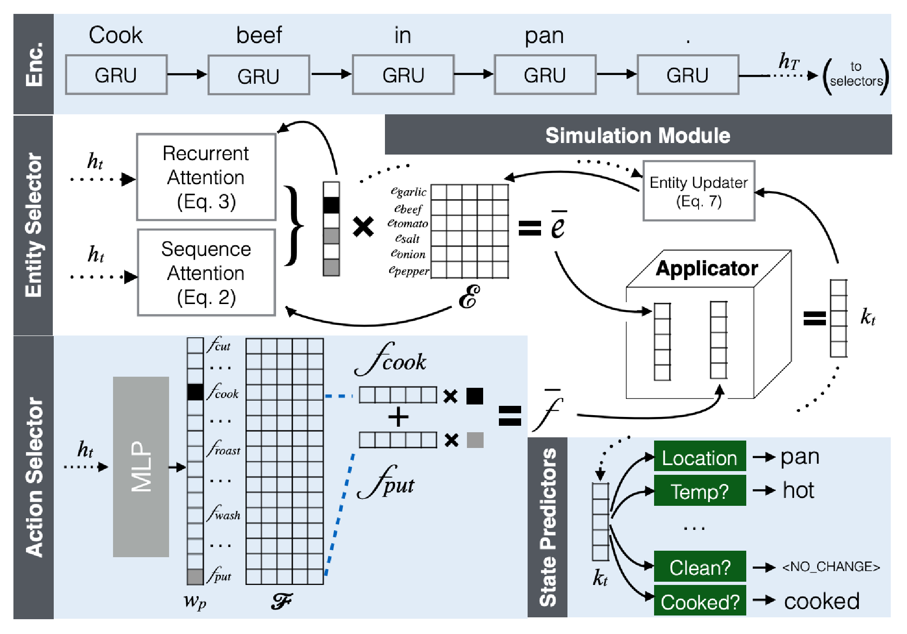

*Simulating Action Dynamics with Neural Process Networks*, Bosselut et al, 2018 <https://arxiv.org/pdf/1711.05313.pdf>

* Hafez: a poetry generation system by Ghazvininejad et al
* Main idea: Use a Finite State Acceptor (FSA) to define all possible sequences that obey the desired rhythm constraints. Then use the FSA to constrain the output of a RNN-LM.

**For example:**

* A Shakespearean sonnet is 14 lines of iambic pentameter

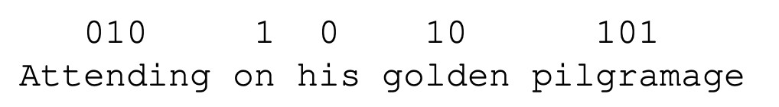

one line of iambic

pentameter

* So the Shakespearean sonnet FSA is ((01)5)14
* During beam search decoding, only explore hypotheses that fall within the FSA.
* Full system:

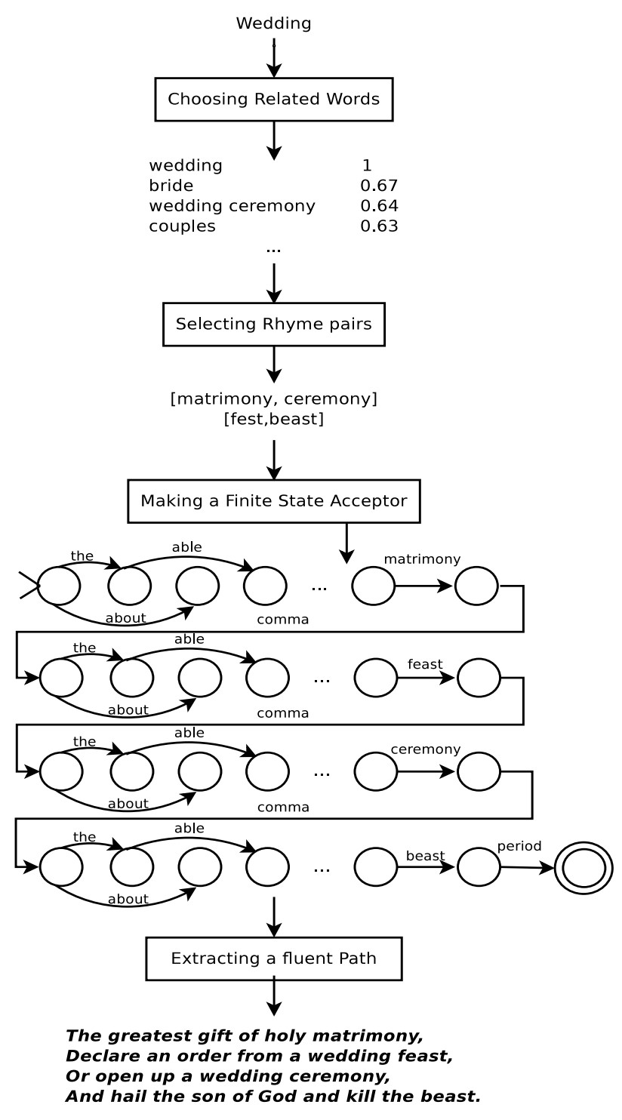

* User provides topic word • Get a set of words related to topic
* Identify rhyming topical words.

These will be the ends of each line

* Generate the poem using RNN-LM constrained by FSA
* The RNN-LM is *backwards* (right-toleft). This is necessary because last word of each line is fixed.

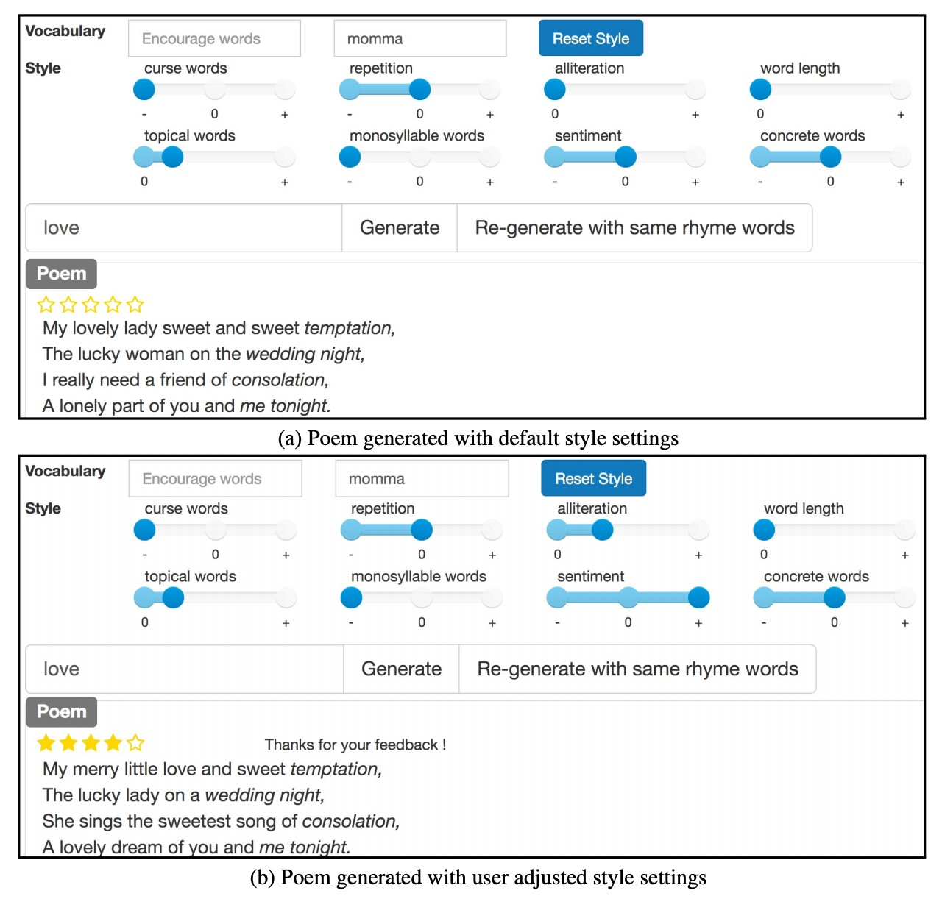In a follow-up paper, the authors made the system interactive and user-controllable.

The control method is simple: during beam search, upweight the scores of words that have the desired features.

# Poetry generation: Deep-speare

|  |  |  |
| --- | --- | --- |
| A more end-to-end approach to poetry generation (Lau et al)  **Three components:** language model pentameter model  rhyme model  … learned jointly as a  multi-task learning  problem |  | |
| Authors find that mete | r and rhyme |  |
| is relatively easy to get | right but the |  |
| generated poems fal | l short on |  |
| “emotion and rea | dability” |  |

•

•

•

*Deep-speare: A joint neural model of poetic language, meter and rhyme*, Lau et al, 2018 <http://aclweb.org/anthology/P18-1181>

# Non-autoregressive generation for NMT

* In 2018, Gu et al published a “Non-autoregressive Neural

Machine Translation” model

* Meaning: it *does not* generate the translation left-to-right, with each word depending on the ones before.
* It generates the translation in parallel!
* This has obvious efficiency advantages, but is also intriguing from a text generation point of view.
* The architecture is Transformer-based; the big difference is that the decoder can run in parallel *at test time*.

*Non-Autoregressive Neural Machine Translation*, Gu et al, 2018 <https://arxiv.org/pdf/1711.02281.pdf>

# Non-autoregressive generation for NMT

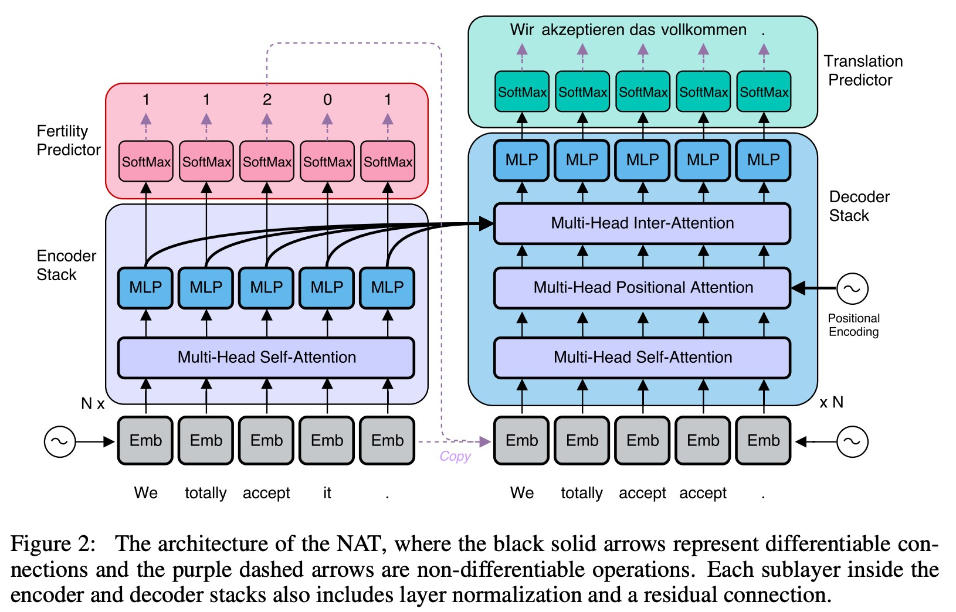

*Non-Autoregressive Neural Machine Translation*, Gu et al, 2018 <https://arxiv.org/pdf/1711.02281.pdf>

**Section 3: NLG evaluation Automatic evaluation metrics for NLG**

Word overlap based metrics (BLEU, ROUGE, METEOR, F1, etc.)

* We know that they’re not ideal for machine translation
* They’re much worse for summarization, which is more openended than machine translation
* Unfortunately, ROUGE also typically rewards extractive summarization systems more than abstractive systems
* And they’re much, much worse for dialogue, which is more open-ended that summarization.
* Similarly for, e.g., story generation

# Word overlap metrics are not good for dialogue

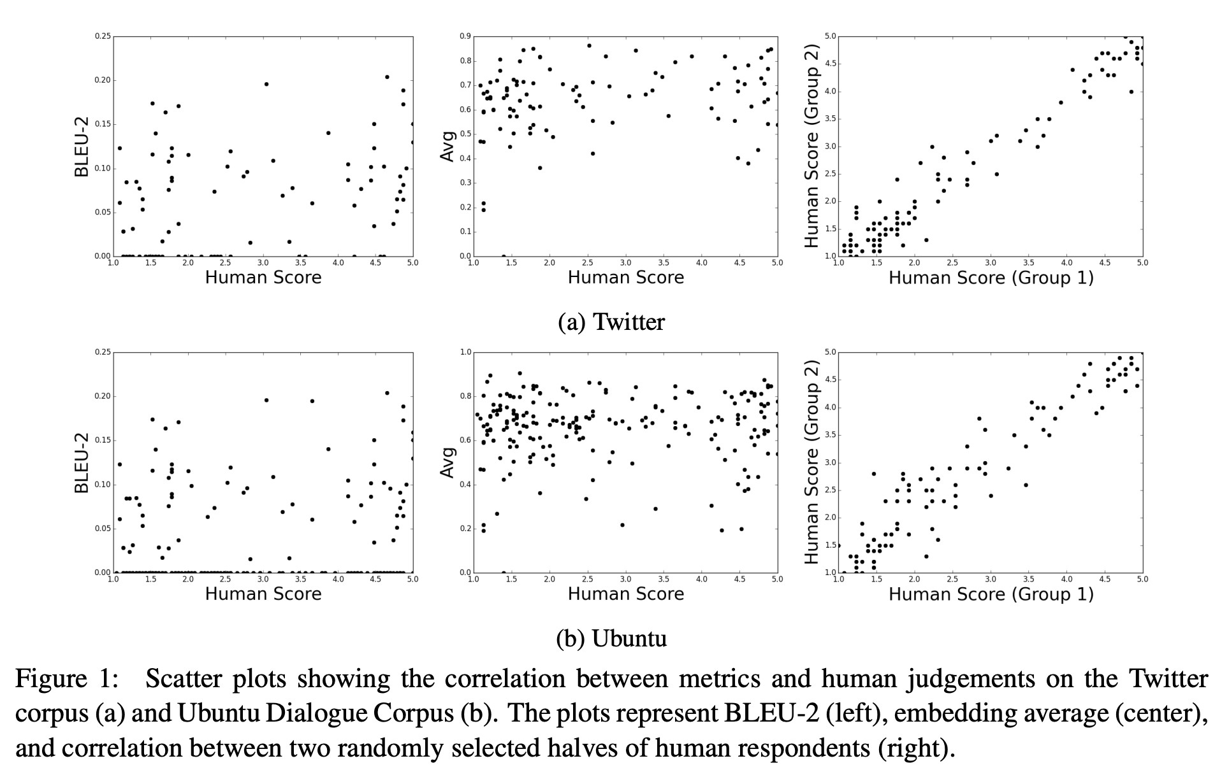

*How NOT To Evaluate Your Dialogue System: An Empirical Study of Unsupervised Evaluation Metrics for Dialogue Response Generation,* Liu et al, 2017 <https://arxiv.org/pdf/1603.08023.pdf>

# Word overlap metrics are not good for dialogue

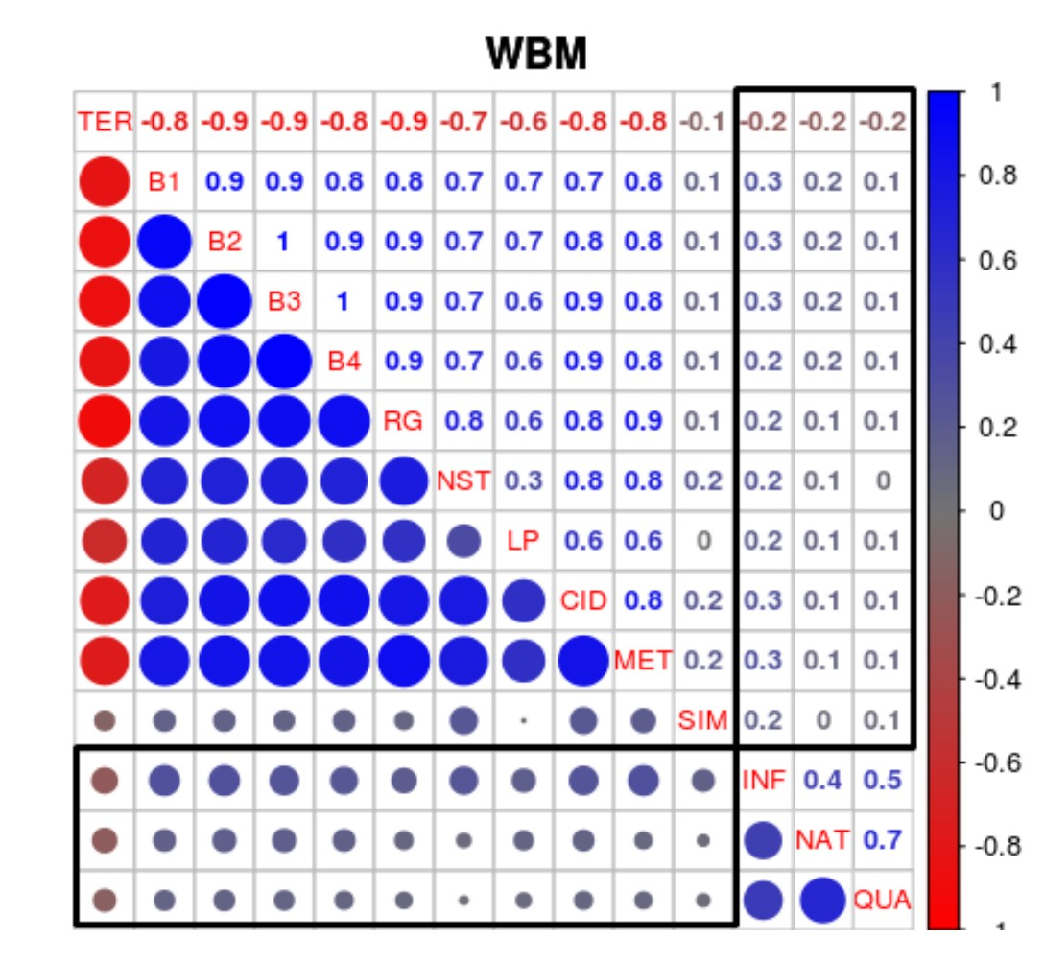

*Why We Need New Evaluation Metrics for NLG*, Novikova et al, 2017 <https://arxiv.org/pdf/1707.06875.pdf>

# Automatic evaluation metrics for NLG

* What about perplexity?
* Captures how powerful your LM is, but doesn’t tell you anything about generation (e.g. if your decoding algorithm is bad, perplexity is unaffected)
* Word embedding based metrics?
* Main idea: compare the similarity of the word embeddings (or average of word embeddings), not just the overlap of the words themselves. Captures semantics in a more flexible way.
* Unfortunately, still doesn’t correlate well with human judgments for open-ended tasks like dialogue.

# Word overlap metrics are not good for dialogue



*How NOT To Evaluate Your Dialogue System: An Empirical Study of Unsupervised Evaluation Metrics for Dialogue Response Generation,* Liu et al, 2017 <https://arxiv.org/pdf/1603.08023.pdf>

# Automatic evaluation metrics for NLG

* We have no automatic metrics to adequately capture overall quality (i.e. a proxy for human quality judgment).
* But we can define more focused automatic metrics to capture particular aspects of generated text:
* Fluency (compute probability w.r.t. well-trained LM)
* Correct style (prob w.r.t. LM trained on target corpus)
* Diversity (rare word usage, uniqueness of n-grams)
* Relevance to input (semantic similarity measures)
* Simple things like length and repetition
* Task-specific metrics e.g. compression rate for summarization
* Though these don’t measure overall quality, they can help us track some important qualities that we care about.

# Human evaluation

* Human judgments are regarded as the **gold standard** • Of course, we know that human eval is slow and expensive
* …but are those the only problems?
* Supposing you do have access to human evaluation: Does human evaluation solve all of your problems?
* **No!**
* Conducting human evaluation effectively is very difficult
* Humans: • are inconsistent
* can be illogical
* lose concentration
* misinterpret your question
* can’t always explain why they feel the way they do
* Results from working on a chatbot project (PersonaChat):
* Investigated controllability (in particular, controlling aspects of the generated utterances such as repetition, specificity, responserelatedness and question-asking).

See et al, 2019

[https://arxiv.org/pdf/1902.08654.pd](https://arxiv.org/pdf/1902.08654.pdf)

[f](https://arxiv.org/pdf/1902.08654.pdf)

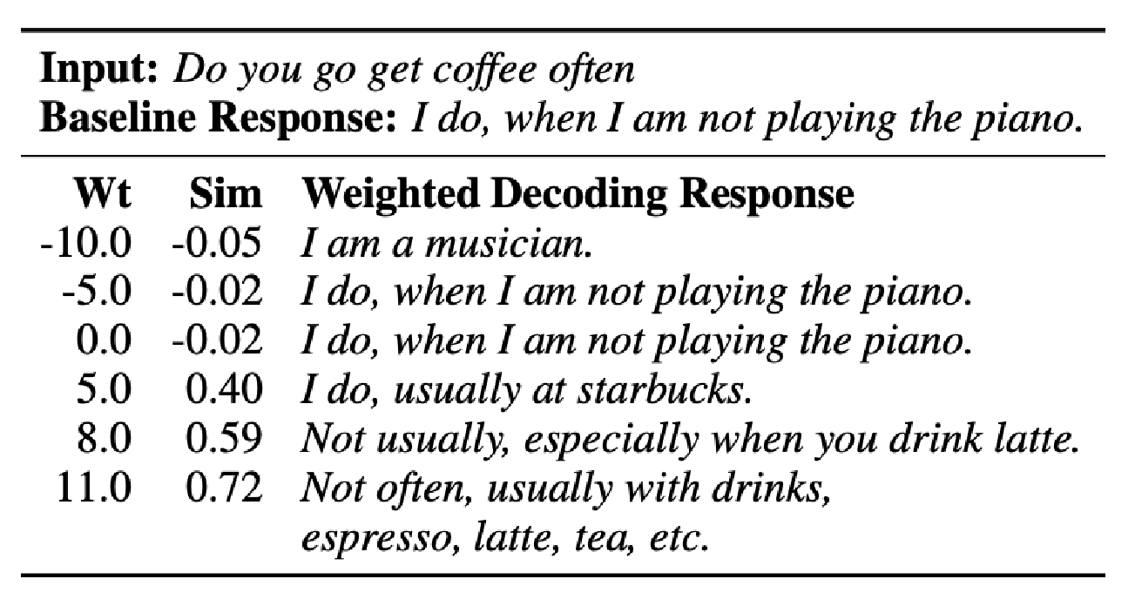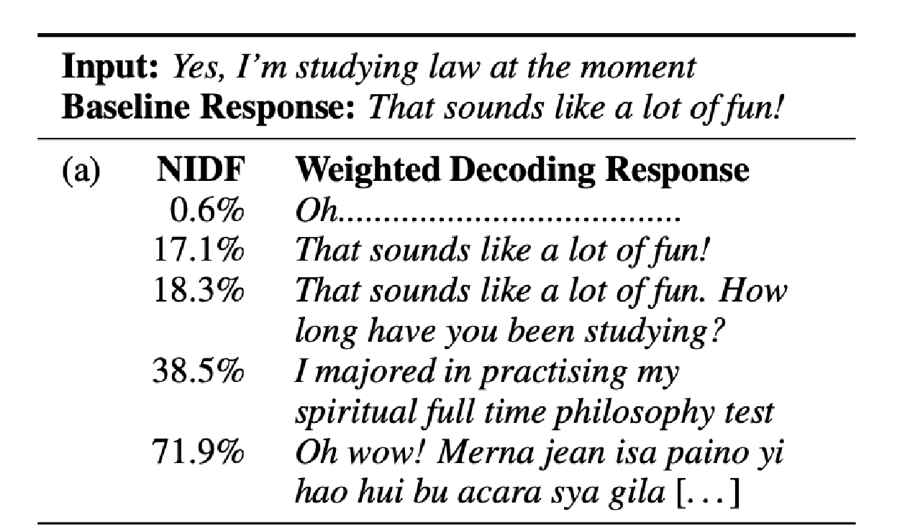

Controlling specificity

Controlling response

-

relatedness

sweet spot

* How to ask for human quality judgments?
* Idea: simple overall quality (multiple-choice) questions like:
* *How well did this conversation go?*
* *How engaging was this user?*
* *Which of these users gave a better response?*
* *Would you want to talk to this user again?*
* *Do you think this user is a human or a bot?*
* **Major problems**:
* Necessarily very subjective
* Respondents have different expectations; this affects their judgments
* Catastrophic misunderstanding of the question (e.g. *“the chatbot was very engaging because it always wrote back”*)
* Overall quality depends on many underlying factors; how should they be weighed and/or compared?

Possible solution: design a detailed human evaluation system that separates out the important factors that contribute to overall chatbot quality:

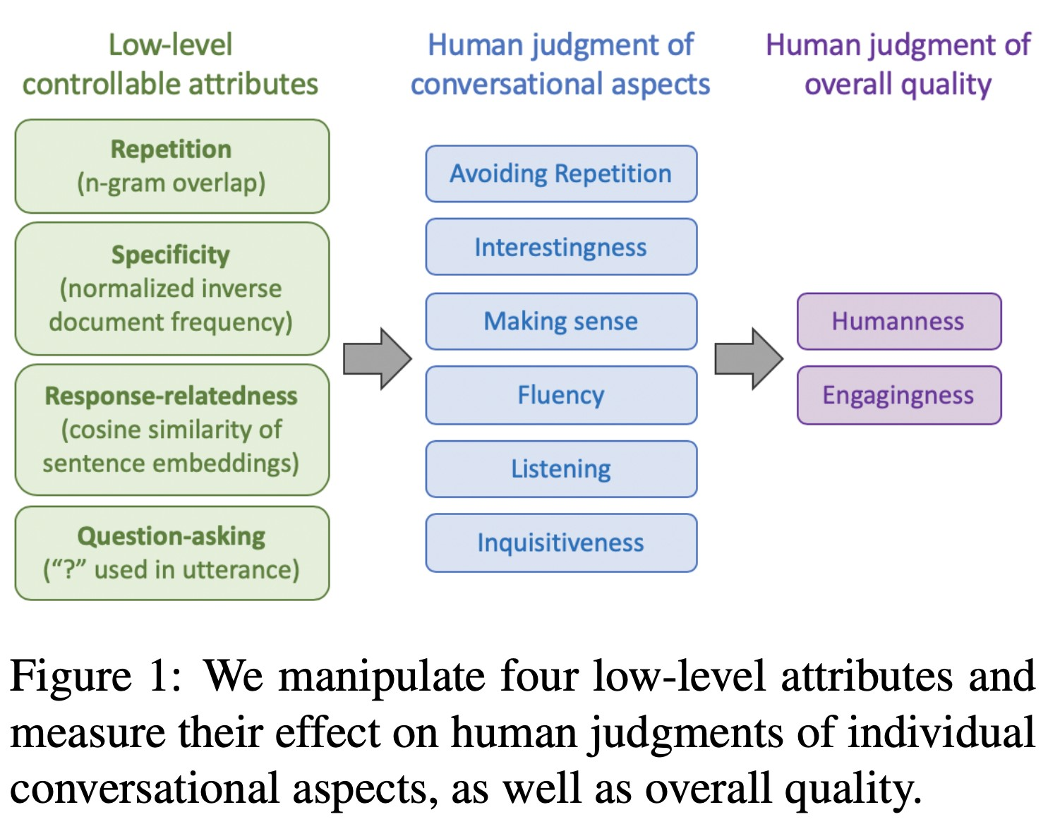

**Findings:**

* Controlling repetition is extremely important for all human judgments
* Asking more questions improves engagingness
* Controlling specificity (less generic utterances) improves engagingness, interestingness and perceived listening ability of the chatbot.
* However, human evaluators have a low tolerance for the risks (e.g.

nonsensical or non-fluent output) associated with the less generic bot

* The overall metric “engagingness” (i.e. enjoyment) is easy to maximize – our bots reached near-human performance
* The overall metric “humanness” (i.e. Turing test) is not at all easy to maximize – all bots are far below human performance
* Humanness is not the same as conversational quality!
* Humans are suboptimal conversationalists: they scored poorly on interestingness, fluency, listening, and asked too few questions.

**Possible new avenues for NLG eval?**

* Corpus-level metrics
* Should an eval metric be applied to each example in the test set independently, or a function of the whole corpus?
* e.g. if a dialogue model always gives the same generic answer to every example in the test set, it should be penalized
* Eval metrics that measure the diversity-safety tradeoff
* Human eval for free
* Gamification: make the task (e.g. talking to a chatbot) fun, so humans provide supervision and implicit evaluation for free
* Adversarial discriminator as an evaluation metric
* Test whether the NLG system can fool a discriminator which is trained to distinguish human text from artificially generated text

**Section 4:**

**Thoughts on NLG research, current trends, and the future**

# Exciting current trends in NLG

* Incorporating discrete latent variables into NLG
* May help with modeling structure in tasks that really need it, like storytelling, task-oriented dialogue, etc
* Alternatives to strict left-to-right generation
* Parallel generation, iterative refinement, top-down generation for longer pieces of text
* Alternative to maximum likelihood training with teacher forcing
* More holistic sentence-level (rather than word-level) objectives

**NLG research: Where are we? Where are we going?**

* ~5 years ago, NLP + Deep Learning research was a wild west



* Now, it’s a lot less wild
* …but NLG seems like one of the wildest parts remaining

Image credit: mstodt on Pixabay

# Neural NLG community is rapidly maturing

* During the early years of NLP + Deep Learning, community was mostly transferring successful NMT methods to NLG tasks.
* Now, increasingly more inventive NLG techniques emerging, specific to *non-NMT* generation settings.
* Increasingly more (neural) NLG workshops and competitions, especially focusing on open-ended NLG:
* NeuralGen workshop
* Storytelling workshop
* Alexa Prize: <https://developer.amazon.com/alexaprize>
* ConvAI2 NeurIPS challenge
* These are particularly useful to organize the community, increase reproducibility, standardize eval, etc.
* The biggest roadblock for progress is eval

# 8 things we’ve learned from working in NLG

1. The more open-ended the task, the harder everything becomes.
   * Constraints are sometimes welcome!
2. Aiming for a specific improvement can be more manageable than aiming to improve overall generation quality.
3. If you’re using an LM for NLG: improving the LM (i.e. perplexity) will most likely improve generation quality.
   * ...but it's not the only way to improve generation quality.
4. Look at your output, a lot

# 8 things we’ve learned from working in NLG

1. You need an automatic metric, even if it's imperfect.
   * You probably need *several* automatic metrics.
2. If you do human eval, make the questions as focused as possible.
3. Reproducibility is a huge problem in today's NLP + Deep Learning, and a huger problem in NLG.
   * Please, publicly release all your generated output along with your paper!
4. Working in NLG can be very frustrating. But also very funny…

# Bizarre conversations with my chatbot



